Minesweeper

1. Member

- Trương Công Trung - ITITIU19059

- Nguyễn Vĩnh Trí - ITDSIU19021

1. List of functions in this demo

- MainGame.BeginGameProcess.UI()

- MainGame.BeginGameProcess.Reset()

- MainGame.BeginGameProcess.RandomBomb()

- MainGame.BeginGameProcess.B_Click()

1. Demo

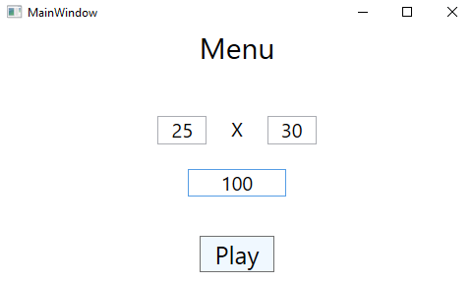

Figure Prepare window of Game

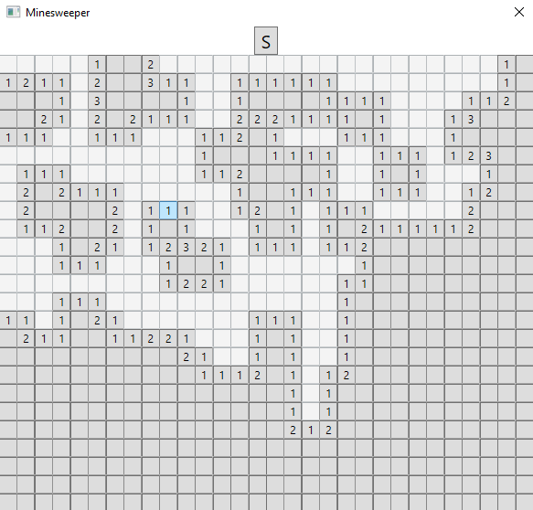

Figure Main window of Game

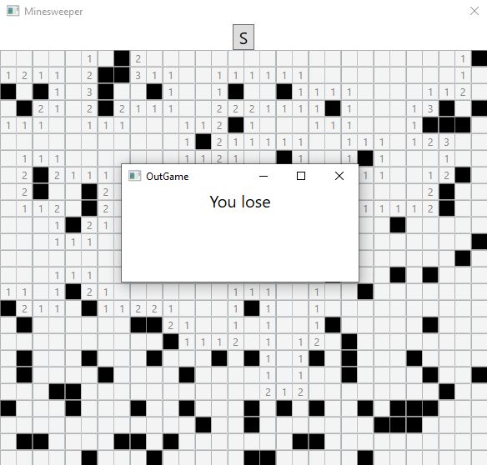

Figure Lose window

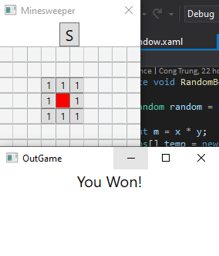

Figure Win window

1. The design
   1. Algorithms

- BFS to spread an empty cell.

* 1. Data Structure

- class Pos: save the position of a cell.

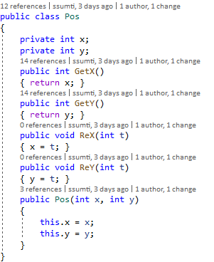

- class Queues: to implement the BFS algorithms.

